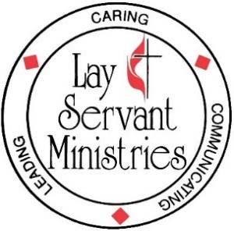
Lay Servant Ministries School
Spring 2024 April 6 and April 7
Greenwood District

Book List for Advanced Lay Servant School Classes
You only need to order the book for the class you are taking

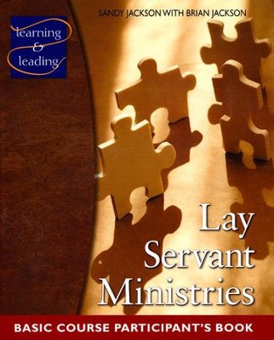

Lay Servant Ministries Basic Course

By: Sandra Jackson, Brian Jackson

Lay Servant Ministries – Basic Course Sandy Zeigler Jackson and Brian Jackson Participant’s Book • DR626 • 978-0-88177-626-3 •

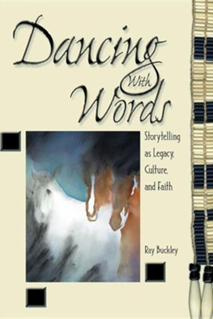

Dancing with Words: Storytelling as Legacy, Culture, and Faith
By: Ray Buckley
Dancing with Words Ray Buckley Participant’s Book • DR407 • 978-0-88177-407-8 •

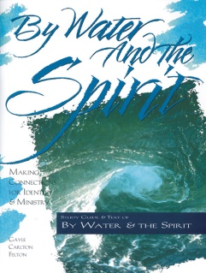
Sacraments: Means of Grace
(order both books)

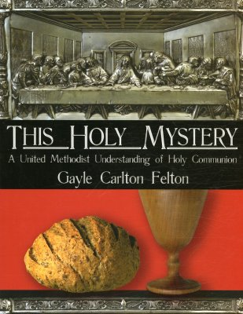

By Water and the Spirit Gayle Carlton Felton Participant’s Book • 978-0-88177-201-2
By Water and the Spirit – Available as PDF download at Discipleship Ministries | By Water and the Spirit - Full Text (in… (umcdiscipleship.org)

AND

This Holy Mystery: A United Methodist Understanding of Holy Communion Gayle Carlton Felton Participant’s Book • 978-0-88177-457-3
This Holy Mystery- Available as PDF download at
Discipleship Ministries | This Holy Mystery: A United Methodist… (umcdiscipleship.org)

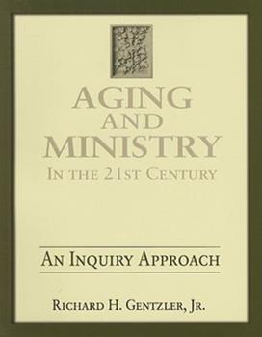
Aging and Ministry in the 21st Century Richard H. Gentzler, Jr. Participant’s Book • DR540 • 978-0-88177-540-2

Please read as much of the book as possible prior to class

Upper Room Ministries
800-972-0433
Fax: 615-340-7275
Online: http://bookstore.upperroom.org
Mail: Upper Room/Discipleship Resources PO Box 340012, Nashville, TN 37203-9540

Cokesbury
800-672-1789
Online: http://www.cokesbury.com
Mail: 201 Eighth Avenue South
PO Box 801
Nashville, TN 37202-0801

Amazon
Online: www.amazon.com

https://www.thriftbooks.com

https://www.christianbook.com/

