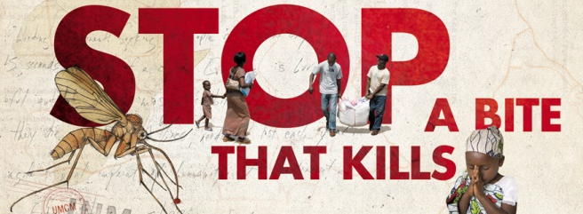

Dear Local Vendor,

Do you want to save millions of lives? World Malaria Day is Monday, April 25, and the United Methodist Church in South Carolina would like to partner with you by directing our members, family, friends and neighbors all across the state to eat at your establishment on Monday, April 25 to support Imagine No Malaria on World Malaria Day 2016. Imagine No Malaria is a global health initiative of the United Methodist Church that has pledged $75 million to help end needless deaths from malaria. Malaria is 100% preventable, treatable and beatable, but it still kills almost half a million people. 78% percent of those deaths are children under the age of 5. Our efforts to end deaths through Imagine No Malaria are concentrated in Africa where 90% of the world’s deaths from malaria occur and where a child dies every 2 minutes—720 children a day—from a tiny mosquito bite. On April 25 all 233,000+ United Methodists around South Carolina have been challenged to raise awareness and funds for the life-saving work of Imagine No Malaria, believing that together we can make malaria history as it is in our own country.

We would like to partner with you in this healing and hopeful work by giving a portion of your proceeds on World Malaria Day, Monday, April 25, to Imagine No Malaria. We will advertise and direct our members and their friends and family to any partnering restaurant that has pledged a portion of their World Malaria Day proceeds to Imagine No Malaria. You just tell us the who, what, when and where, and we’ll get the word out all over South Carolina and provide you with promotional materials! It’s a win-win-win for everyone: you will get great business, advertisement and a tax write-off for your charitable contribution, our stomachs will be filled with great food, and we will be saving lives in Africa by coming together on Monday, April 25 for a bite to eat to stop a bite that kills. We will literally be changing the world and saving lives by coming together to share a meal in South Carolina. Your support of Imagine No Malaria would be greatly appreciated. 100% of your charitable contribution will go to Imagine No Malaria, and you will receive an acknowledgement letter for your charitable donation upon receipt of your gift. If you would like to participate, please complete the enclosed “INM World Malaria Day” form and email or mail by March 21, 2016.

You can learn more about life-giving work of Imagine No Malaria at www.ImagineNoMalaria.org or please feel free to contact me, the South Carolina Field Coordinator for Imagine No Malaria. Thank you for your consideration!

Sincerely,

Rev. Jeri Katherine W. Sipes
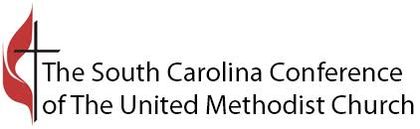
(803) 381-6622
jksipes@umcsc.org
www.INM.UMCSC.org
WORLD MALARIA DAY, APRIL 25, 2016

Business/Organization Name:______________________________________________________

Address:_______________________________________________________________________

Contact Person(s):_______________________________________________________________

Phone:_______________________ Email:____________________________________________

Website:_______________________________________________________________________

Facebook_____________________________ Twitter___________________________________

Check
- Yes! We will participate in World Malaria Day on Monday, April 25, and a portion of the proceeds will be given to Imagine No Malaria.
Choose
- Breakfast
- Lunch
- Dinner
- All Day
Choose
- We will contribute _________% of the lunch proceeds to Imagine No Malaria.
- We will contribute _________/person eating lunch with us on April 25.
- We will give a portion of the proceeds from the purchase of _______________________
____________________________________________________________ on our menu.
- We will give a flat charitable donation of __________ to Imagine No Malaria.
- Other:__________________________________________________________________

Name:______________________________________________________ Date:______________

Signature:_____________________________________________________________________

Please submit this form and send a JPEG copy of your business logo to jksipes@umcsc.org by March 21, 2016. Please make charitable donations to The South Carolina Annual Conference, and mail to The United Methodist Conference Center, attn: Imagine No Malaria, 4908 Colonial Drive, Columbia, SC 29203. Upon receipt of your charitable donation, you will receive an acknowledgement letter. Thank you for participating in World Malaria Day and supporting the work of Imagine No Malaria!

